Cost-effectiveness analysis of non-surgical periodontal treatment for preventing strokes and myocardial infarctions in the UK
Abstract
Purpose
Methods
Results
Conclusions
Introduction
The economic burden of cardiovascular disease (CVD) in the UK is significant, despite falling incidence and mortality rates in recent years [1]. The total costs of coronary heart disease (CHD) and stroke in England are forecast to reach £19.6 billion and £15.9 billion, respectively [2]. CVDs cause approximately 25% of all deaths in the UK and significantly raise an individual’s likelihood of developing vascular dementia [3]. Despite a 30% fall in CVD incidence between 2000 and 2019, the economic burden remains high [4]. As CVD affects a large proportion of the population, preventive measures must be cost-effective and deliver health gains beyond CVD, leading to downstream cost reductions.
Periodontal disease (PD) affects at least 50% of people in the UK, with severe periodontal pocketing expected to increase by 56.7% by 2050 [5,6]. A growing number of longitudinal cohort studies and randomised controlled trials supports evidence that treating PD can lower risk of CVD. Non-surgical periodontal therapy (NSPT) has been found to reduce cardiovascular biomarkers in patients with stable coronary artery disease, and to improve endothelial function in patients with a recent myocardial infarction and severe PD [7,8,9]. A meta-analysis found significant reductions in interleukin-6 and systolic blood pressure levels in the treated groups [10]. In patients that have suffered a recent stroke, both standard and intensive PD treatment reduced later stroke and MI mortality [11]. A limitation of trial studies is short follow-up time and small patient pool, therefore longitudinal evidence has to be used to establish stronger causal links. A meta-analysis of longitudinal studies calculated that the risk of all incident CVD was 22% higher in individuals with PD, and the risk of incident CVD increased ascendingly with PD severity [12]. A further review showed consistent findings when stratified by sex and by specific CVD event (CHD; OR = 1.19, 95% CI: 1.09-1.3 and stroke; OR = 1.29, 95% CI: 1.09-1.53) [13]. A US-based study with 21-years of follow up found PD and caries associated with an increased risk of ischemic stroke (HR 1.86; 95% CI 1.32-2.61) [14]. None of these studies explicitly assess the cost-effectiveness of treating PD to prevent CVD events, and since healthcare budgets are expected to become more constrained as the population ages cost-effectiveness will continue to be important to health policy decision makers[15]. The consistent causal link between CVD and PD highlights the potential benefit that population-level PD interventions can have on reducing CVD risk and mortality.
A prior UK study found NSPT cost-effective for improving glycated haemoglobin in Type 2 diabetes [16], and a US analysis suggested PD therapy is cost-effective in reducing diabetes-related microvascular disease [17]. Whether periodontal therapy is cost-effective as a CVD prevention strategy remains unknown.
We use a Markov model approach to estimate to what extent NSPT for adults with severe PD will have a downstream effect on reducing the costs of later CVD events. Long-term costs and effects, using quality-adjusted life years (QALYs), will provide a valuation of NSPT’s role in CVD burden management. Ischaemic stroke and myocardial infarction (MI) will be modelled as the CVD outcomes arising from PD risk.

Methods
Model structure
We constructed a Markov model with 1 year cycles over 10 years to estimate the incremental costs and health outcomes associated with severe PD treated with NSPT to prevent CVD events. We decided to simulate an aggregate population level rather than at an individual level as we are evaluating a population-level policy question which does not require individual-level heterogeneity.
The model has eight mutually exclusive health states: No prior CVD (base), Post-Stroke (year 1 tunnel), Post-Stroke (year 2+), Post-MI (year 1 tunnel), Post-MI (year 2+), Post-Both (year 1 tunnel), Post-Both (year 2+), and Death (absorbing). Individuals enter the model with no prior history of CVD and can experience stroke, MI, both events or death during each cycle. We chose a tunnel system to represent temporary health states to allow us to capture acute-phase costs and utilities. CVD event costs and mortality are much higher in the initial onset year compared to subsequent years, therefore, tunnel states provide a more accurate estimation of costs [18,19]. We assumed no recurrent events in Post-both year 1. Tunnel states relax the memoryless property while retaining time-since-event effects; tunnel duration was one cycle with death as the only competing exit.
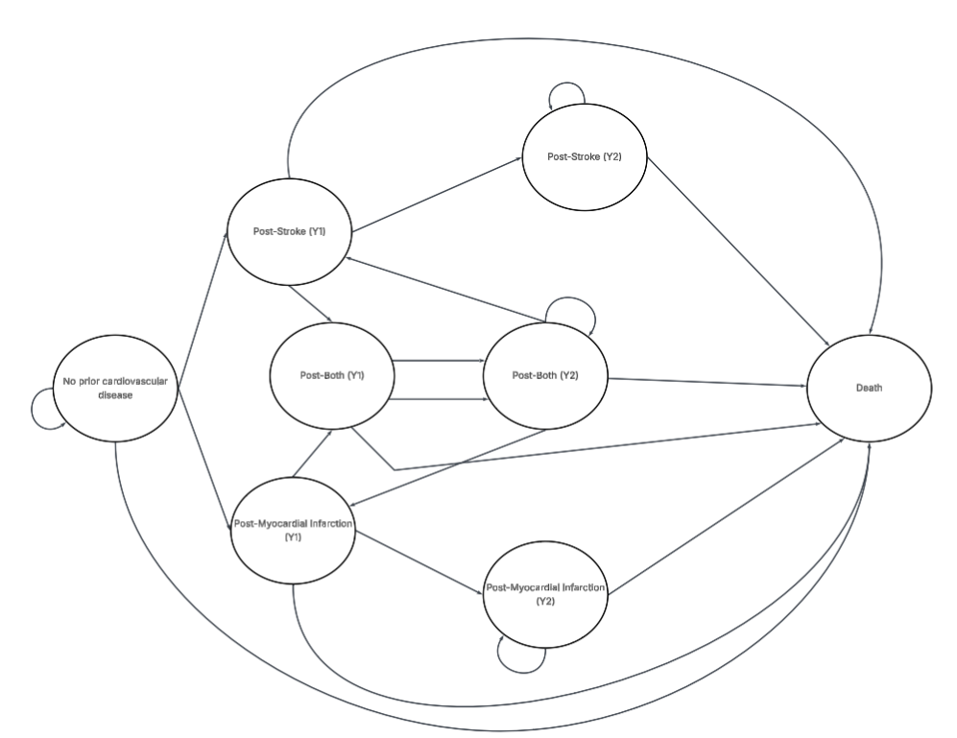
Figure 1 Markov model flow diagram

We modelled base utilities for a 65-year old male. No sex-specific differences NSPT effects have been found [20]. The decision to model at aged 65 and for a horizon of 10 years was justified by the expected onset, survival rates and recurrent events for an individual after a stroke or MI [21,22]. The rate of fatal stroke and MI events was given as 10% and 14%, respectively, from recent studies [23,24]. The background death probability was calculated from Office of National Statistics life tables [25].
Baseline stroke and MI hazards in the base state were calculated from literature that provided the risk of onset events for individuals over 60 years old with severe PD [26, 27]. This was cross checked with a retrospective study that assessed by how much severe PD increased the incidence of the respective CVD event [28]. State-specific hazard multipliers captured elevated risks of subsequent CVD events after a prior event, reflecting disease progression.
NSPT treatment effects were applied to the treatment arm using hazard ratios (HR) obtained from existing literature. These hazards are not based on a UK population, but cover a significant cumulative sample size (n=1,263,988). Therefore, given the absence of longitudinal data for the UK and our use of probabilistic sensitivity analysis (PSA) we deemed them appropriate to use despite the parameter uncertainty. There are varied estimates for the size of the impact that NSPT has on CVD events. Retrospective and prospective cohort studies of adults with PD who have had regular NSPT treatment have found lower hazards of stroke of 0.40-0.78 (95% CI 0.29-0.81) relative to untreated PD [29,30]. Non-surgical treatment has been found to lower the hazard of MI by 0.54-0.90 (95% CI 0.44-0.95) relative to untreated PD [31,32]. The included studies primarily involved older adults with later stage PD who received regular NSPT treatment. Given the heterogeneity in study populations and follow-up durations, the median of reported HRs was used as a summary estimate for base-case analysis. Treatment effects only had an effect on the chance of stroke and myocardial infarction, background death hazard remained constant throughout. Treatment includes one initial periodontal treatment for the horizon, maintenance therapy every six months and re-treatment, extraction, resin-bonded bridge and the removal of a partial denture every year. This is in line with NHS and dental periodontal treatment protocol [33,34].

Health utilities and costs
We adopted the NHS payer perspective and reported costs and QALYs in accordance with National Institute for Health and Care Excellence (NICE) guidance [35]. This does not capture the true costs to clinicians and society, as it omits opportunity costs and nom-medical costs. This perspective is most relevant for reimbursement decisions and has been the most common perspective in dental health economics [36].
Base costs for non-surgical treatment were taken from a previous cost-effectiveness study, inflated to 2024 costs, and cross referenced with current NHS Dental band costs and procedure to ensure accuracy [16,37,38]. Expected procedures per cycle are found in Table X. We calculated the expected per-cycle cost of NSPT per patient. Full calculations are found in the supplementary information (pp.xx-xx). The use of pre-calculated costs from previous cost-effectiveness analysis ensured replicability and comparability of our results.
Procedure | Total Cost (£) | Expected per cycle (1 year) | Expected costs per cycle (£)
Initial periodontal treatment | 530.75 | 0.1 | 53.07
Periodontal re-treatment | 265.37 | 1 | 265.37
Periodontal maintenance | 35.90 | 0.5 | 17.95
Extraction | 71.99 | 1 | 71.79
Resin-bonded bridge | 382.04 | 1 | 382.04
Removable partial denture | 484.60 | 1 | 484.60
Table X Per cycle 2024 costs associated with non-surgical periodontal treatment

Stroke and myocardial infarction (MI) costs for each health state were obtained from contemporary literature and applied to the relevant model states [18,39,40,41]. All individuals experiencing a stroke or MI were assumed to receive treatment within the NHS. Costs were inflated to 2024 prices, with long-term costs assigned to chronic post-event states. These included NHS social care costs. A one-off acute cost was applied during the cycle in which the event occurred. These estimates were cross-checked for consistency against the National Stroke Audit Programme [42]. Where costs were stratified by age and sex we chose the costs most applicable to a 65-year old male. For individuals who experienced both a stroke and a MI, we assigned the higher of the two event costs (post-stroke) to ensure full capture of healthcare resource use. This approach avoids underestimation of costs when overlapping conditions occur, given the lack of a clear consensus on combining costs for multimorbidity in health economic evaluations [43].
All QALY values were derived from EQ-5D sources. The decision to use 1 year as a cycle length was based on the available data for costs and QALYs associated with CVDs [19,44]. There was found to be minimal difference between the health state of an individual 3 months after a stroke or MI, compared to 9 to 12 months after, which supports the decision to use a year for the Markov states. The health utility values for post-stroke and post-MI for the immediate post-event state were obtained from a single study reporting quality of life impacts for CVD on individuals in the UK [19]. Values for stroke events were cross referenced with values estimated in a meta-analysis [44]. MI utility values were verified with those used in a lipid-lowering cost-effectiveness analysis which we also used costs for [41]. The multiplicative approach was taken to calculate the utility values for post-both events for first year state and subsequent years state. This approach has been found to perform best for combined health states of two conditions simultaneously [45]. A one off disutility effect for each acute event was attached to the event states [44, 46].
Full costing breakdown and QALY utility values can be found in the supplementary information (pp.xx-xx). All cost and QALY outcomes were discounted at the suggested rate of 3.5% for NHS evaluations [35].

Outcomes
Model results included total discounted QALYs, costs and the incremental cost-effectiveness ratio (ICER). The intervention was considered cost-effective if the ICER was below the NICE threshold of £20,000-£30,000 per QALY gained. Net monetary benefit was also calculated which allows for comparisons without the use of ratios.
We carried out this evaluation in line with the Consolidated Health Economic Evaluation Reporting Standards (CHEERS) 2022 checklist. The CHEERS 2022 checklist for this study has been completed and can be found in the supplementary material (pp.xx-xx). The model was built in Microsoft Excel.

Sensitivity Analysis
One-way sensitivity analysis was used to evaluate the impact of changing single parameter values. The maximum and minimum values within a range were used to test uncertainties associated with costs, utilities and transitional probabilities. Periodontal and CVD treatment costs were varied by ±10% of the base case value. Utility and disutility values were tested using the provided confidence intervals.
We performed PSA to evaluate the robustness of the results, given treatment effect data is not from the UK. The β-distribution was used for utility and transition probabilities. The γ-distribution was used for costs. We ran 10,000 Monte Carlo simulations with the value of each model input being randomly drawn from the assigned parametric distribution. A cost-effectiveness plane and cost-effectiveness acceptability curve were drawn using these results.

Results
Base case analysis
Table X provides the 10-year costs, accumulated QALYs, incremental costs, incremental QALYs and ICER of NSPT on CVD events. Treatment was associated with a £5,600 higher cost and 0.18 additional QALY per patient treated. This resulted in an ICER of £31,381 per QALY gained, above the NICE threshold of £20,000-£30,000. Given this, NSPT to reduce MI and stroke would not be deemed cost-effective under base-case assumptions. This results in a negative net monetary benefit of -£246 at the upper limit of the £30,000 threshold.
Group | Cost (£) | Incremental Cost (£) | QALYs | Incremental QALYs | ICER (£)
Base | 17,998 |  | 6.94
Treated | 23,599 | 5,600 | 7.11 | 0.18 | 31,381
Table X Results of base-case cost-effectiveness analysis
Treatment resulted in a 41% fall in non-fatal stroke incidence and a 24% fall in non-fatal MI events over the simulated 10-years. By year 10, 53% of individuals in the treatment arm had experienced no CVD events versus 39.7% in the untreated arm. Cumulative all-cause mortality was lower in the treatment group by 13% at 10 years.

Sensitivity analysis
Figure X shows the results of our one-way sensitivity analysis. None of the hazard multipliers by state had an effect of over ±1% on the final ICER. Changing the treatment HR for both MI and stroke had the largest effect on the model outcomes. A stroke treatment effect ranging from 0.29-0.81 gave an ICER range of £8,762-£66,826, and a MI treatment effect range of 0.44-0.95 gave £16,855-£71,729. Only under the most optimistic treatment effects did the ICER fall below £20,000/QALY. The model was moderately sensitive to changing utility values. Most utility values showed less than 5% variation in final ICER calculations. Applying a range of 0.79-0.87 of the base state utility changed the ICER by -17% to 2%. Altering the disutility of an acute stroke event had a much larger effect than changing MI disutility, which provided a ±1% difference to the final ICER value. Changing the cost of the post-stroke (Y2) state showed the largest variation out of all the costs, most of which were unresponsive to sensitivity. Changing MI and stroke acute costs, by ±10% each, had a minimal effect on the final ICER. Altering the discount rate to 2% and 5% did not have an effect on the final results.

Figure X Tornado Plot Of One-Way Sensitivity Analysis For Selected Variables

Figure X shows the effect of changing the cost of periodontal treatment on its cost-effectiveness. For this treatment to be cost-effective in preventing MI and stroke events, it would need to have a per-cycle cost of approximately £1,240. Per-cycle NSPT is currently £1,274.82 given the expected procedures per cycle in Table X (Methodology section).

Figure X Effect of per cycle treatment cost on cost-effectiveness
Figure X and Figure XX reports the results of our PSA. Given a cost-effectiveness threshold range of £20,000-£30,000, NSPT was cost-effective in 46.72%-72.04% of the runs. In 99.45% of runs NSPT was more effective and more costly, but only 36.16% of runs resulted in an ICER less than £30,000. Table X provides the results of the PSA.
Mean Incremental Cost (£) | Mean Incremental QALYs | Mean ICER (£)
8,138 | 0.40 | 24,915
Table X PSA Results
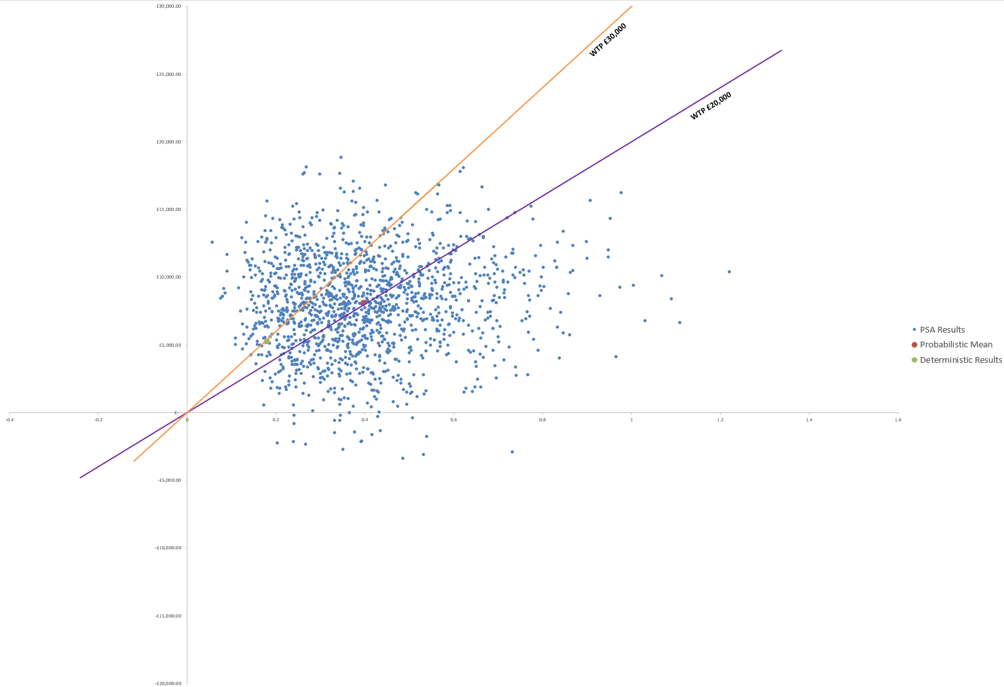
Figure X Cost-effectiveness plane
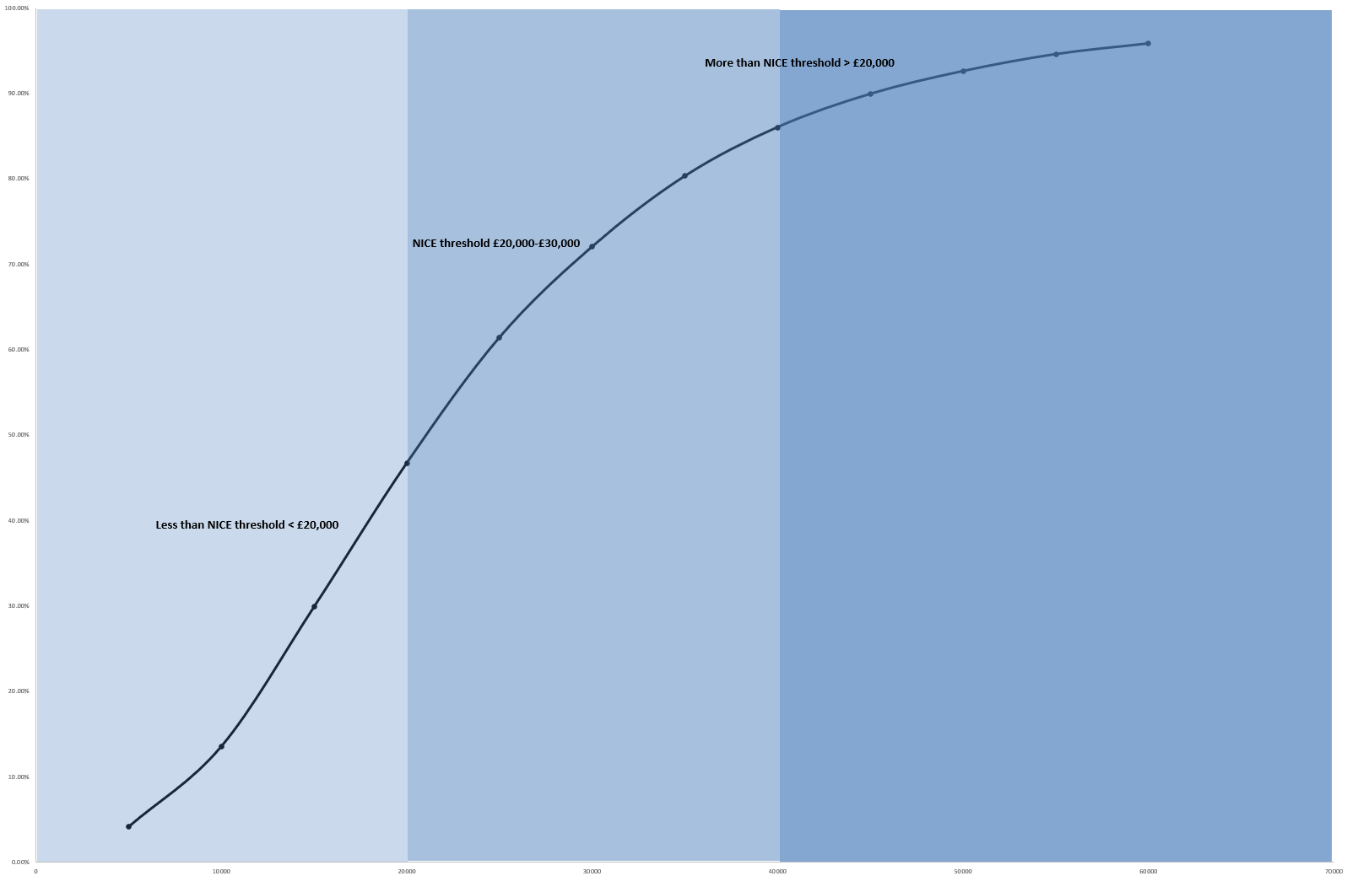
Figure X Cost-effectiveness acceptability curve

Discussion
To our knowledge, this is the first study to assess the cost-effectiveness of non-surgical periodontal treatment on preventing MI and stroke in a UK population. The 37% and 23% fall in non-fatal stroke and MI incidence over a 10-year period demonstrates the impact that treating periodontal disease can have on CVD. However, these avoided events translated to only 0.16 QALYs gained per person, highlighting that the health benefit was modest relative to the cost.
The ICER range resulting from the sensitivity analysis of the two treatment effect parameters has highlighted the uncertainty around the effectiveness of non-surgical periodontal treatment. We used wide testing intervals for the treatment effects, but this was to reflect the uncertainty surrounding the magnitude of treatment effects. Using optimistic published hazard reductions (stroke HR ~0.29, MI HR ~0.44) drove the ICER below £20,000, whereas using the higher end (HR ~0.8–0.9) made the intervention not cost-effective. The estimated level of clinical benefit at an incremental cost of £5,600 emphasizes the need for greater clinical trials and cohort studies investigating the effects of periodontal treatment beyond oral health benefits. This will reduce the parameter uncertainty around treatment effects which will result in more precise economic evaluation of periodontal treatments.
Using our base case analysis assumptions, NSPT would need to decrease to a cost of £1,240 to result in an ICER of £29,496. This cost reduction could be achieved through shorter dental appointments or less frequent checkups, however, this would impact NSPT effectiveness. In the context of the NHS, any form of periodontal treatment often involves patient co-payments, lowering the cost to the NHS. NSPT as a method of preventing future CVD events could be covered with co-payments and therefore proved cost-effective if further health benefits beyond oral health and CVD events are also accounted for.
Previous economic studies have focused on diabetes-related outcomes which limits comparisons. Choi et al found that expanding periodontal treatment in a US population was cost-saving in averting tooth loss and microvascular disease, with the majority of healthcare cost saving coming from averting tooth loss [17]. This approach simulated by individual rather than an aggregate population due to their testing of correlations between demographic characteristics and chronic disease risks obtained from the National Health and Nutrition Examination Survey (NHANES) (2009-2014). A UK model by Solowiej-Wedderburn found periodontal treatment in a 58-year old man with type 2 diabetes (HbA1c 7%-7.9%) to have an ICER of £28,000, with health gains larger in patients with higher HbA1c [16]. These attributed savings helped to improve glycaemic control, suggesting that periodontal therapy’s value is greater when considering the benefits beyond CVD alone. Our CVD model did not find cost savings, highlighting the context of wider outcome measures. Future studies should utilise blood pressure measurements as a model outcome due to their role in diagnosing CVD and diabetes-related diseases. This continuous variable can provide more accurate insights into the impact of NSPT while providing evidence for a wider range of policy applications.

Limitations
The most significant limitation of our study is the uncertainty surrounding NSPT’s effect on CVD events. There is an absence of UK-based RCTs with sufficient follow up, or prospective longitudinal studies that control for confounders at baseline, to provide robust evidence of the size of the treatment effect. To address this uncertainty, we examined a wide range of NSPT effects sizes, shown by Figure X and Figure XX.
The scope of this study was to evaluate the cost-effectiveness of non-surgical periodontal treatment on fatal and non-fatal CVD events. Therefore, our results do not include the patient-level benefits of non-surgical periodontal treatment on severe periodontal disease. This makes our QALY gained estimations to be underestimates of total health benefits, however, this was out of the study scope. Direct utility gains from reduced tooth pain, tooth retention, and better chewing function and nutrition are not captured in this analysis. Including these gains would improve the cost-effectiveness of periodontal treatment, but widen the scope beyond CVD outcomes.
Individuals with severe PD treated with non-surgical periodontal therapy with other comorbid conditions might see wider health improvements such as improved hypertension and endothelial function [47]. Widening the scope of analysis to include these health benefits emphasises a drawback of modelling cost-effectiveness at an aggregate Markov model level.
A horizon of 10-years could be insufficient to capture all relevant benefits of periodontal therapy. Despite the discussed rationale for choosing 10-years as the time to model over, a lifetime horizon could show more QALYs gained from avoided CVD events. A suggestion for future studies would be to model for the intervention at an earlier age, allowing for greater accumulation of health benefits. Modelling at an aggregate Markov level does not account for individual patient-level factors that could affect treatment effectiveness, despite the evaluation targeting a population-level policy. However, a UK-based longitudinal study on NSPT’s effect size does not exist which is why we chose not to use a microsimulation evidence-based risk model. A longitudinal study such as that would also help to reduce the uncertainty surrounding NSPT’s effect on cardiovascular risk.

References
[1] Shih K, Herz N, Sheikh A, O'Neill C, Carter P, Anderson M. Economic burden of cardiovascular disease in the United Kingdom. Eur Heart J Qual Care Clin Outcomes. 2025 Feb 24;qcaf011. https://doi.org/10.1093/ehjqcco/qcaf011
[2] Landeiro F, Harris C, Groves D, O’Neill S, Jandu KS, Tacconi EM, Field S, Patel N, Göpfert A, Hagson H, Leal J. The economic burden of cancer, coronary heart disease, dementia, and stroke in England in 2018, with projection to 2050: an evaluation of two cohort studies. Lancet Healthy Longev. 2024 Aug 1;5(8):e514–23.
[3] British Heart Foundation. UK Cardiovascular Disease Factsheet. London: British Heart Foundation; 2025 Sep. Available from: https://www.bhf.org.uk/-/media/files/for-professionals/research/heart-statistics/bhf-cvd-statistics-uk-factsheet.pdf?rev=0759fdcb1d3248f9b9331c4039e6075c&hash=B0C8BEA1A48B306E4D2FC73C4265FBFA (Accessed 27 October 2025).
[4] Conrad N, Molenberghs G, Verbeke G, Zaccardi F, Lawson C, Friday JM, Su H, Jhund PS, Sattar N, Rahimi K, Cleland JG. Trends in cardiovascular disease incidence among 22 million people in the UK over 20 years: population based study. BMJ. 2024 Jun 26;385: e075210.
[5] Department of Health and Social Care, NHS England. Delivering better oral health: an evidence-based toolkit for prevention. Chapter 5: periodontal diseases. London: Department of Health and Social Care; updated 10 September 2025. Available from: https://www.gov.uk/government/publications/delivering-better-oral-health
[6] Elamin A, Ansah JP. Projecting the burden of dental caries and periodontal diseases among the adult population in the United Kingdom using a multi-state population model. Front Public Health. 2023;11:1190197. doi:10.3389/fpubh.2023.1190197
[7] Montenegro MM, Ribeiro IW, Kampits C, Saffi MA, Furtado MV, Polanczyk CA, Haas AN, Rösing CK. Randomized controlled trial of the effect of periodontal treatment on cardiovascular risk biomarkers in patients with stable coronary artery disease: preliminary findings of 3 months. J Clin Periodontol. 2019 Mar;46(3):321–31.
[8] H. Bokhari SA, Khan AA, Butt AK, Azhar M, Hanif M, Izhar M, Tatakis DN. Non‐surgical periodontal therapy reduces coronary heart disease risk markers: a randomized controlled trial. Journal of clinical periodontology. 2012 Nov;39(11):1065-74.
[9] Lobo MG, Schmidt MM, Lopes RD, Dipp T, Feijó IP, Schmidt KE, Gazeta CA, Azeredo ML, Markoski M, Pellanda LC, Gottschall CA. Treating periodontal disease in patients with myocardial infarction: a randomized clinical trial. Eur J Intern Med. 2020 Jan 1;71:76–80.
[10] Meng R, Xu J, Fan C, Liao H, Wu Z, Zeng Q. Effect of non-surgical periodontal therapy on risk markers of cardiovascular disease: a systematic review and meta-analysis. BMC Oral Health. 2024 Jun 14;24(1):692.
[11] Sen S, Curtis J, Hicklin D, Nichols C, Glover S, Merchant AT, Hardin JW, Logue M, Meyer J, Mason E, Huang DY. Periodontal disease treatment after stroke or transient ischemic attack: the PREMIERS Study, a randomized clinical trial. Stroke. 2023 Sep;54(9):2214–22.
[12] Larvin H, Kang J, Aggarwal VR, Pavitt S, Wu J. Risk of incident cardiovascular disease in people with periodontal disease: a systematic review and meta-analysis. Clin Exp Dent Res. 2021 Feb;7(1):109–22.
[13] Leng Y, Hu Q, Ling Q, Yao X, Liu M, Chen J, Yan Z, Dai Q. Periodontal disease is associated with the risk of cardiovascular disease independent of sex: a meta-analysis. Front Cardiovasc Med. 2023 Feb 27;10:1114927.
[14] Wood S, Logue L, Meyer J, Moss K, Beck JD, Johansen MC, Rosamond WD, Sen S. Combined influence of dental caries and periodontal disease on ischemic stroke risk. Neurology Open Access. 2025 Oct 22;1(4):e000036.
[15] Rachet-Jacquet L, Rocks S, Charlesworth A. Long-term projections of health care funding, bed capacity and workforce needs in England. Health Policy. 2023 Jun 1;132:104815.
[16] Solowiej‐Wedderburn J, Ide M, Pennington M. Cost‐effectiveness of non‐surgical periodontal therapy for patients with type 2 diabetes in the UK. J Clin Periodontol. 2017 Jul;44(7):700–7.
[17] Choi SE, Sima C, Pandya A. Impact of treating oral disease on preventing vascular diseases: a model-based cost-effectiveness analysis of periodontal treatment among patients with type 2 diabetes. Diabetes Care. 2020 Mar 1;43(3):563-71.
[18] Patel A, Berdunov V, Quayyum Z, King D, Knapp M, Wittenberg R. Estimated societal costs of stroke in the UK based on a discrete event simulation. Age Ageing. 2020 Feb 27;49(2):270–6.
[19] Lui JN, Williams C, Keng MJ, Hopewell JC, Sammons E, Chen F, Gray A, Bowman L, Landray SM, Mihaylova B; REVEAL Collaborative Group. Impact of new cardiovascular events on quality of life and hospital costs in people with cardiovascular disease in the United Kingdom and United States. J Am Heart Assoc. 2023 Oct 3;12(19):e030766.
[20] Angelov N, Soldatos N, Ioannidou E, Carter TC, Shimpi N, Applegate J, Kookal KK, Parsegian K. A retrospective analysis of the role of age and sex in outcomes of non-surgical periodontal therapy at a single academic dental center. Sci Rep. 2024 Apr 25;14(1):9504.
[21] Hall M, Smith L, Wu J, Hayward C, Batty JA, Lambert PC, Hemingway H, Gale CP. Health outcomes after myocardial infarction: a population study of 56 million people in England. PLoS Med. 2024 Feb 15;21(2):e1004343.
[22] Shavelle RM, Brooks JC, Strauss DJ, Turner-Stokes L. Life expectancy after stroke based on age, sex, and Rankin grade of disability: a synthesis. J Stroke Cerebrovasc Dis. 2019 Dec 1;28(12):104450.
[23] Morgan A, Sinnott SJ, Smeeth L, Minassian C, Quint J. Concordance in the recording of stroke across UK primary and secondary care datasets: a population-based cohort study. BJGP Open. 2021 Apr 1;5(2):BJGPO.2021.0011.
[24] Allara E, Shi W, Bolton T, Chalmers F, Brizzi LF, Musto L, Shah AS, Tomlinson C, Walter I, Conrad N, Danesh J. Burden of cardiovascular diseases in England (2020–24): a national cohort using electronic health records data. Lancet Public Health. 2025 Nov 1;10(11):e943–54.
[25] Office for National Statistics. National life tables: UK [Internet]. London: Office for National Statistics; 18 March 2025 [cited 2025 Oct 23]. Available from: https://www.ons.gov.uk/peoplepopulationandcommunity/birthsdeathsandmarriages/lifeexpectancies/datasets/nationallifetablesunitedkingdomreferencetables
[26] Zemedikun DT, Chandan JS, Raindi D, Rajgor AD, Gokhale KM, Thomas T, Falahee M, De Pablo P, Lord JM, Raza K, Nirantharakumar K. Burden of chronic diseases associated with periodontal diseases: a retrospective cohort study using UK primary care data. BMJ Open. 2021 Dec 1;11(12):e048296.
[27] Wagner AK, D'Souza M, Bang CN, Holmstrup P, Blanche P, Fiehn NE, Gislason G, Pedersen CT, Damgaard C, Nielsen CH, Hansen PR. Treated periodontitis and recurrent events after first-time myocardial infarction: a Danish nationwide cohort study. J Clin Periodontol. 2023 Oct;50(10):1305–14.
[28] Cho HJ, Shin MS, Song Y, Park SK, Park SM, Kim HD. Severe periodontal disease increases acute myocardial infarction and stroke: a 10-year retrospective follow-up study. J Dent Res. 2021;100(7):706–13. doi:10.1177/0022034520986097
[29] Lee YL, Hu HY, Huang N, Hwang DK, Chou P, Chu D. Dental prophylaxis and periodontal treatment are protective factors to ischemic stroke. Stroke. 2013 Apr;44(4):1026–30. doi:10.1161/STROKEAHA.111.000076
[30] Kim YR, Son M, Kim SR. Association between regular dental scaling and stroke risk in patients with periodontal diseases: evidence from a Korean nationwide database. Epidemiol Health. 2025 Apr 19;47:e2025020.
[31] Kao YW, Shia BC, Chiang HC, Chen M, Wu SY. Association of tooth scaling with acute myocardial infarction and analysis of the corresponding medical expenditure: a nationwide population-based study. Int J Environ Res Public Health. 2021;18(14):7613. https://doi.org/10.3390/ijerph18147613
[32] Lee YL, Hu HY, Chou P, Chu D. Dental prophylaxis decreases the risk of acute myocardial infarction: a nationwide population-based study in Taiwan. Clin Interv Aging. 2015 Jan 6;10:175–82. doi:10.2147/CIA.S67854
[33] Department of Orthodontics and Restorative Dentistry, Glenfield Hospital. Periodontal treatment protocol. Leicester: Glenfield Hospital; [year unknown].
[34] NHS England. Avoidance of doubt: provision of phased treatments. London: NHS England; 2021 Jul 8 [cited 2025 Oct 27]. Available from: https://www.bsperio.org.uk/assets/downloads/B0615-Update-to-NHS_avoidance-of-doubt-provision-of-phased-treatments-July-2021.pdf
[35] National Institute for Health and Care Excellence (NICE). Developing NICE guidelines: the manual. NICE process and methods [PMG20]. London: NICE; 2014 Oct 31.
[36] Schwendicke F, Rossi JG, Göstemeyer G, Elhennawy K, Cantu AG, Gaudin R, Chaurasia A, Gehrung S, Krois J. Cost-effectiveness of artificial intelligence for proximal caries detection. J Dent Res. 2021 Apr;100(4):369–76.
[37] HM Treasury. GDP deflators at market prices, and money GDP: March 2025 (Spring Statement & Quarterly National Accounts) [Internet]. London: HM Treasury; 2025 Mar [cited 2025 Oct 24]. Available from: https://www.gov.uk/government/statistics/gdp-deflators-at-market-prices-and-money-gdp-march-2025-spring-statement-quarterly-national-accounts
[38] National Health Service (England). How much NHS dental treatment costs. London: NHS; [cited 2025 Oct 27]. Available from: https://www.nhs.uk/nhs-services/dentists/how-much-nhs-dental-treatment-costs/
[39] Danese MD, Gleeson M, Kutikova L, et al. Estimating the economic burden of cardiovascular events in patients receiving lipid-modifying therapy in the UK. BMJ Open. 2016;6(8):e011805.
[40] National Health Service (NHS). 2020/21 national cost collection for the NHS. London: NHS England; [cited 2025 Oct 27]. Available from: https://www.england.nhs.uk/costing-in-the-nhs/national-cost-collection/
[41] Morton JI, Marquina C, Lloyd M, Watts GF, Zoungas S, Liew D, Ademi Z. Lipid-lowering strategies for primary prevention of coronary heart disease in the UK: a cost-effectiveness analysis. Pharmacoeconomics. 2024 Jan;42(1):91–107.
[42] Xu XM, Vestesson E, Paley L, Desikan A, Wonderling D, Hoffman A, Wolfe CD, Rudd AG, Bray BD. The economic burden of stroke care in England, Wales and Northern Ireland: using a national stroke register to estimate and report patient-level health economic outcomes in stroke. Eur Stroke J. 2018 Mar;3(1):82–91. doi:10.1177/2396987317746516
[43] Lomas J, Asaria M, Bojke L, Gale CP, Richardson G, Walker S. Which costs matter? Costs included in economic evaluation and their impact on decision uncertainty for stable coronary artery disease. Pharmacoeconomics Open. 2018 Dec;2(4):403–13.
[44] Joundi RA, Adekanye J, Leung AA, et al. Health state utility values in people with stroke: a systematic review and meta-analysis. J Am Heart Assoc. 2022;11(13):e024296. doi:10.1161/JAHA.121.024296
[45] Thompson AJ, Sutton M, Payne K. Estimating joint health condition utility values. Value Health. 2019 Apr 1;22(4):482–90.
[46] Thom HH, Hollingworth W, Sofat R, Wang Z, Fang W, Bodalia PN, Bryden PA, Davies PA, Caldwell DM, Dias S, Eaton D. Directly acting oral anticoagulants for the prevention of stroke in atrial fibrillation in England and Wales: cost-effectiveness model and value of information analysis. MDM Policy Pract. 2019 Aug;4(2):2381468319866828.
[47] Rodrigues JV, Deroide MB, Sant'ana AP, de Molon RS, Theodoro LH. The role of non-surgical periodontal treatment in enhancing quality of life for hypertensive patients with periodontitis. Rev Odontol UNESP. 2024 Dec 16;53:e20240030.

